Business Report On HBFC Bank (Personal Loans)

Q1. What percentage of the bank’s customers (according to the data) have availed Personal Loans?

In Microsoft Excel, a pivot table can be used to summarize data, such as personal loan statistics. In this case, it shows that 9.60% of individuals have availed a personal loan, while 90.40% have not availed a personal loan.

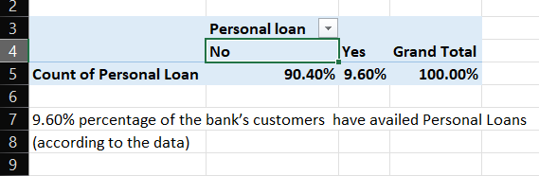

Availed personal loan – 9.60%

Not availed personal loan – 90.40%

Q2. Generate a table with min, max, median & average for all numeric variables (age, experience, income, family members, CCAvg, Mortgage). What are your observations?

I utilized formulas for minimum, maximum, median, and average calculations to analyze data efficiently.

Q3. Create a new categorical variable for Experience using 4 categories –

a. 0 to 10 years

b. 11 to 20 years

c. 21 to 30 years and

d. 30+ years.

Plot a bar graph for this new categorical variable

I used the IFs formula in Excel to categorize income based on multiple conditions, simplifying income analysis.

Then inserted a bar graph from Excel's charts to visually represent data.

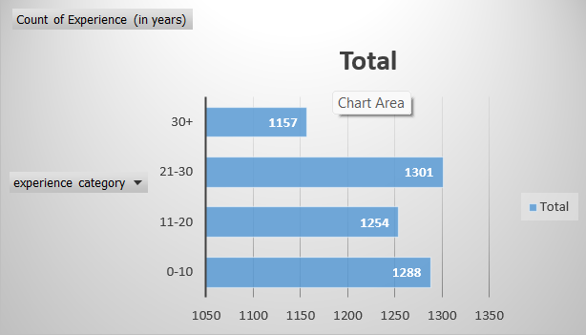

Q4. Create a scatter plot of the Age and the Experience variable. What do you observe?

Through the utilization of a scatter chart in Excel, I visually demonstrated the correlation between age and years of experience among customers, revealing that older customers tend to have more experience, while younger customers typically have less experience.

Q5. What are the top 3 areas (ZIP Codes) where the bank’s customers are located?

I used a pivot table to identify the top three zip codes.

Q6. How many customers have a combination of Fixed Deposits and Credit Cards but not Personal Loan?

Using the IF and AND formulas in Excel, I found that 147 customers have both a credit card and a TD account but have not availed a personal loan.

Q7. What is the median income of the customers who have availed personal loans and compare it with the median income of those customers who have not availed personal loans? What do you infer?

I calculated the median income for customers with and without personal loans using a formula. The result showed that customers with personal loans tend to have a higher median income.

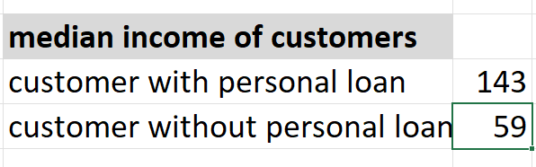

Q8. Create 4 separate Pivot Tables. Summarise your data by percentages. • Education vs Personal Loan • TD Account Vs Personal Loan • Online vs Personal Loan • Income_Category vs Personal Loan

• Education vs Personal Loan :-

By using a pivot table, I discovered that a higher percentage of professionals have availed personal loans compared to graduates and undergraduates,

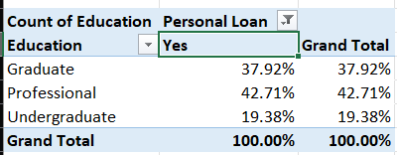

• TD Account Vs Personal Loan:-

Customers without TD accounts have a higher percentage of availed personal loans compared to those with TD accounts.

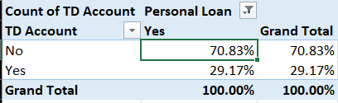

• Online vs Personal Loan:-

Customers with online services have a higher percentage of availed personal loans compared to those who do not use online services.

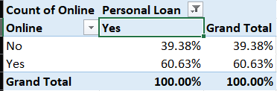

• Income_Category vs Personal Loan :-

The income category with earnings of 100+ has a higher percentage of customers who have availed personal loans compared to other income categories.

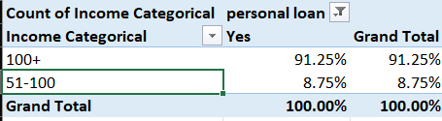

Q9. Analyse the Pivot tables created in the previous question and state any anomaly that you observe. Which categorical variables appear most important for your further study if you want to analyse which customers are most likely to take personal loans and why?

The analysis of pivot table data reveals some key findings. Firstly, professionals are more likely to avail personal loans compared to graduates and undergraduates. Second, customers without TD accounts have a higher rate of personal loan availing than those with TD accounts. Additionally, customers using online services tend to avail personal loans more frequently than those who don't. the analysis indicates that the "100+" income category has a higher percentage of customers availing personal loans compared to other income categories. These insights emphasize the influence of different customer attributes on personal loan

Q10. In the last campaign, bank reached out to 5000 customers out of which 480 customers accepted the personal loan offer. The bank incurred a huge cost in running a marketing campaign to reach out to so many customers. This is where you as a strategic business consultant step in. You are tasked to optimise the cost of this campaign by identifying the correct target base (without significant reduction in number of acceptance of offers). The bank can then send Personal Loan offers to these target customers who have a higher chance of accepting the offer. Based on your analysis, what strategy would you suggest to the management of HBFC bank?

To save money and use our resources wisely for the last campaign, let's target our approach. We'll group customers based on profession, if they have TD bank accounts, how much they use online services, how much they earn, and where they live (with a focus on specific zip codes). Then, we'll create special loan offers for each group to make them more likely to say yes. This way, we'll spend our marketing efforts on the people who are most likely to be interested, saving us money. We should also try selling loans to the 147 customers who already have credit cards and TD accounts but haven't taken personal loans since they already trust our bank. Finally, we'll keep an eye on how well this plan is working and change things if needed.